**Lumine Academy Report**

Lumine academy is an educational website consisting of various learning resources. At the very beginning, I decided to name the website Ignis Vibrante Lumine Academy in honour of my High school which has as motto this phrase. However, the decision made to change the name was purely to emphasize on a shorter and simpler name making it more memorable. People find it easier and faster to admit short and concise names into their memory. The reason behind choosing the word Lumine is due to the fact that Lumine means light in Latin. In my opinion, education brings light to someone’s life.

Besides that, I chose to build an educational website because bestowing knowledge is very important to me. I truly believe that getting proper education is the stepping stone to achieving great success in life. Acquiring knowledge is one of the fundamental ways to build yourself in every aspect of your life and elevate your form of living.

Another reason I chose to do this type of website is because I love to teach. Teaching is one of my passions. I love to share the knowledge I have with other people. Finding ingenuous ways to get the point across to different people also gets my creative juices flowing.

To add to that, I also have some experience in teaching. After I graduated high school, I went back to teach a few high school subjects. Educating the youth of my country was quite a fulfilling experience. It is quite a rewarding feeling when I impart new knowledge upon students, and I see their faces light up in awe or with sudden understanding of a topic previously unknown. It was also amazing to hear the questions asked by some students that I may not have thought of myself. My days as a high school teacher was a learning experience for me as well and further deepened my appreciation and passion of education.

I also believe in different types of education resources. Everybody learns differently and the intake of knowledge is a very subjective matter. Some people learn better with visual stimulation, some learn better with audio stimulation and sometimes it is a combination of different types of educational resources that stimulates the brain enough for the most effective way to absorb knowledge. To cater for this, there are various resources easily available to educate ourselves. For example, there are e-books, videos, exercises, past examination papers and so on to help students get educated. This is the reason I created this website as it has multiple resources for students to use to the best of their understanding.

Ultimately, I want students to achieve academic success. I want other students to share this passion and fervour for knowledge with me. It is the driving factor as to why I decided to make this website. I have made it in a way that is easy to use and very conducive for studying. Hopefully, this inspires and motivates students to study hard and do well.

The following are the requirements of the website and detailing of these components:

* A homepage consisting of a section on about us, also a navigation to move between the webpages, a grid of pictures portraying the diverse background of students and an inspiration quote of Malala followed by a click here button directing to the subjects list.
* Subjects list page consisting of all the subjects the website offers for student to learn.
* Subject-wise pages (each subject has their own webpage) consisting of the resources (videos, eBooks, exercises, past paper) available to study.
* Subject’s resource-wise pages (each subject’s resources have unique webpage) consisting of all the links to access the resources’ websites.
* Sign in or Register page consisting of the sign in form and the registration form.
* Contact page consisting of our contact details and a form to send us any enquiring.

Changes done on initial website (project1):

* Adding a navigation menu bar on all webpages of the website to allow users to move between home, courses’ page and contact page more easily. Thus, this allow a more effective and quick access as well as use of all the content of the webpage.
* The name of the website from Ignis Vibrante Lumine Academy to Lumine academy to make the name of the website simple and easy to remember.
* Adding a search bar to allow the users to easily search and access the subject’s content. (This feature is not yet functioning)
* Changing the colour idea of the website from red as shown in the first web project storyboard to an amalgam of white, blue, and orange shades. My choices regarding the colour scheme of the website were made based on the psychology of colour. So the background picture consists of mainly yellow and oranges shades as they are fun and motivating colours. The header and font colour are of blue shades which are said to improve focus, reduce stress and support study. [116][117]
* Adding sign in button to access the sign in page.
* Creation of sign in webpage to allow user to log in or sign up. This user log in system will allow user to have access to resources they saved or notes they wrote and saved. For the time being, only the registration and log in system have been set up but the website does not consist of the user webpage for him to save resources or his work.
* Removal of all the subject-wise forum and created only a contact page where the user can specify the subjects, they are having issues in and send us a message.
* The presentation of the links changed from a simple text to pictures in the subjects list pages, the subject-wise pages, and the subjects’ resources page. This was done because the pictures give a captivating visual appealing to the taste of the youngsters and it is much more easily read.
* Instead of adding all my contact details in the footer, I added all this information in the contact page.

Outline and structure of the website:

Homepage:

The logo header always directs to the home page this is the case for every webpage in this site

A search bar allowing users to search the website’s content. But this feature is not functioning, and the search button is a dummy one.

This is the navigation menu consisting of home button which links to the homepage, course button, having a submenu of all the subjects shown below , link to the subject list page and the contact button linking to the contact page.

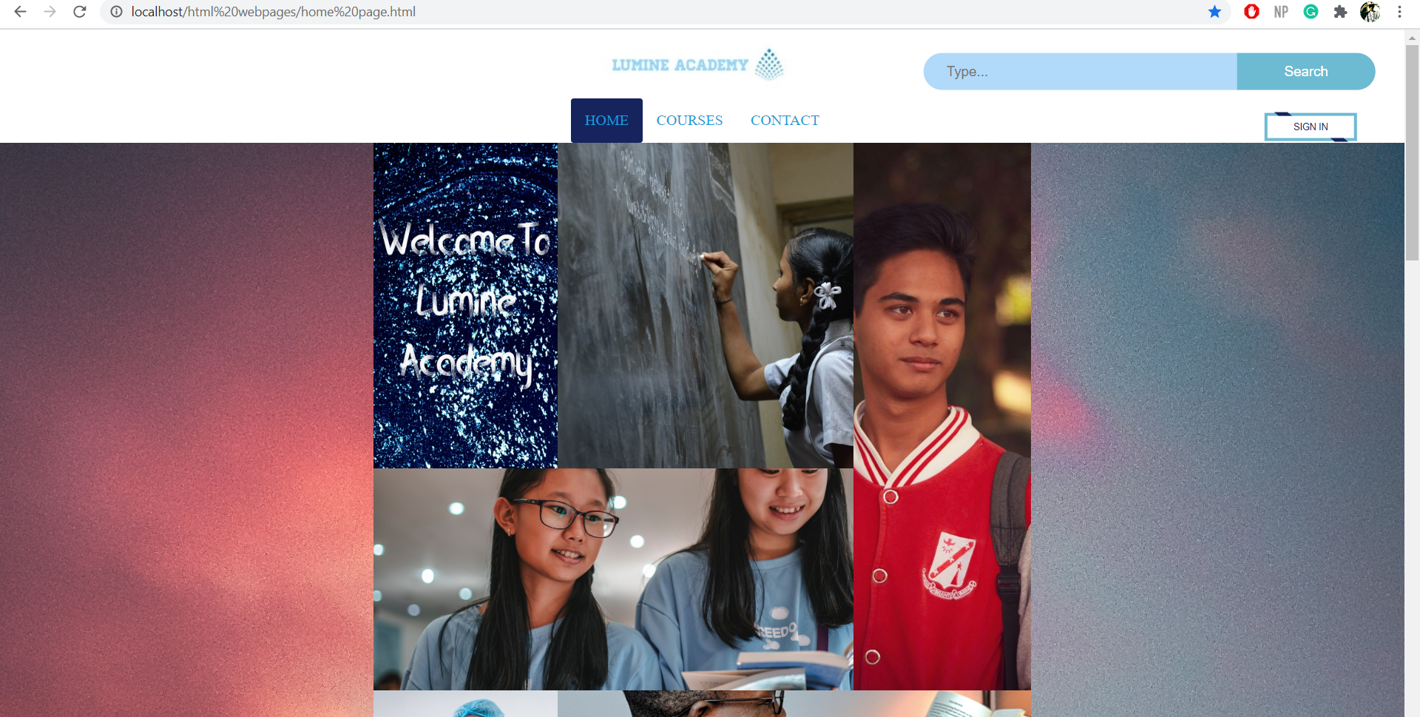

The sign in button directs the user to the sign in/register page.

This is the submenu of the course division in the navigation bar. Each subject direct to its respective subject webpage.

The use of grid of picture to keep good quality images.

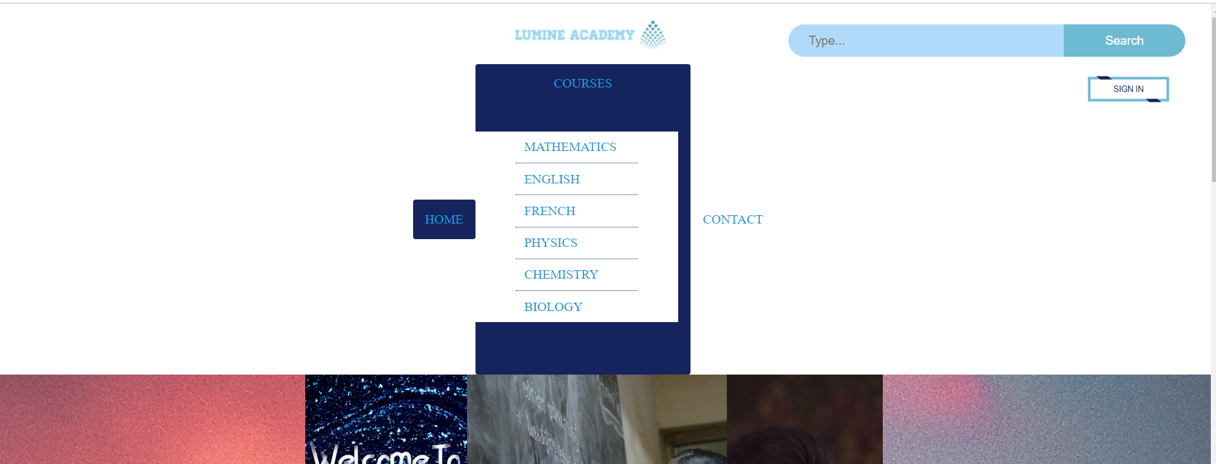

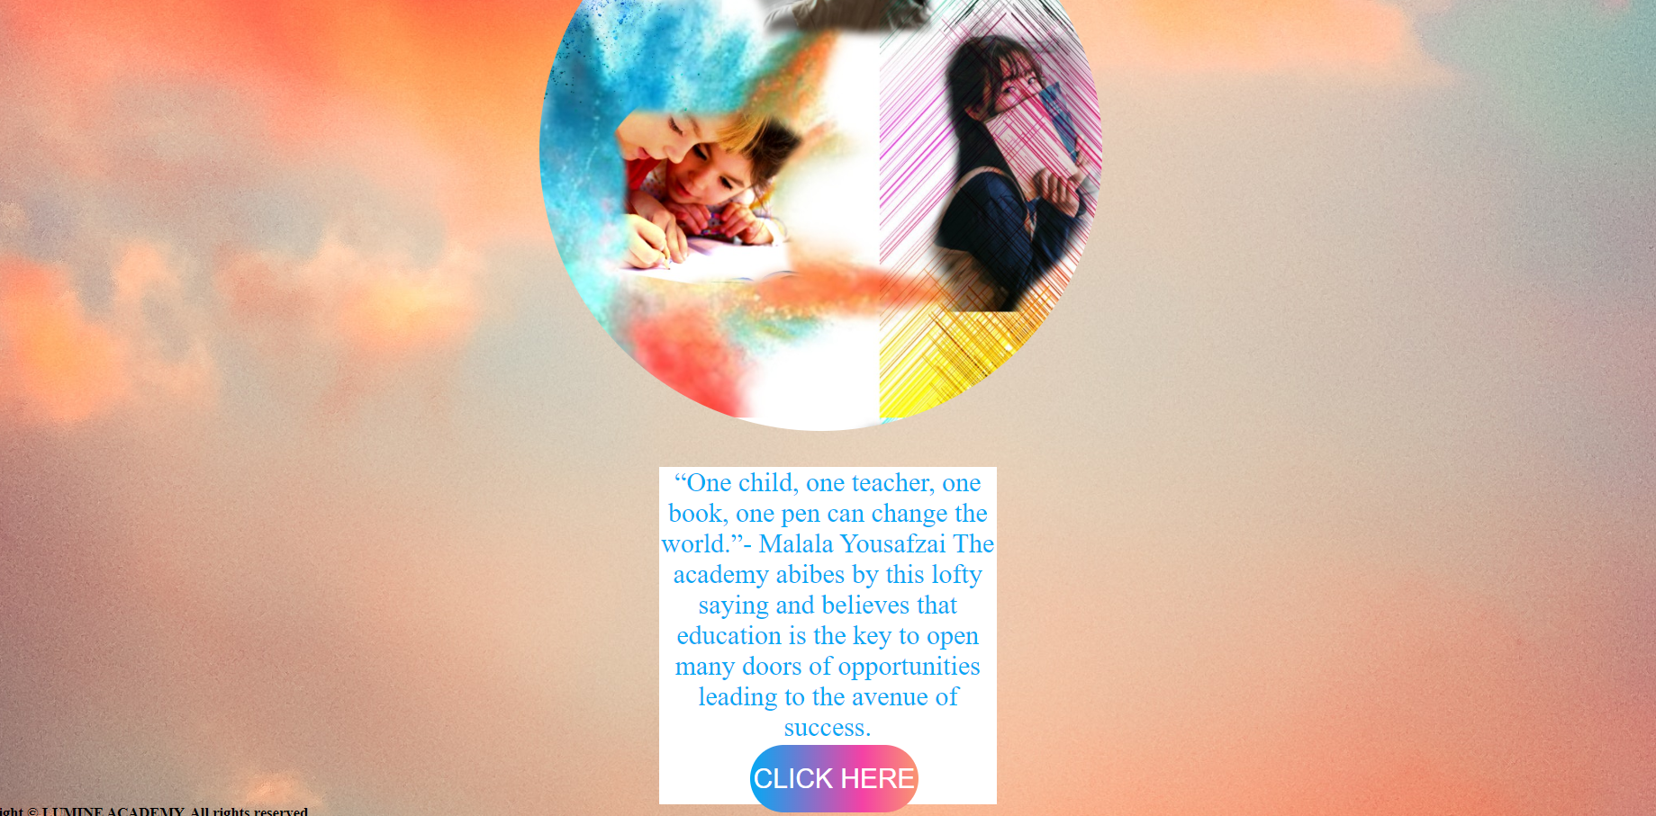

This button directs you to the subject list page.

Subject list page:

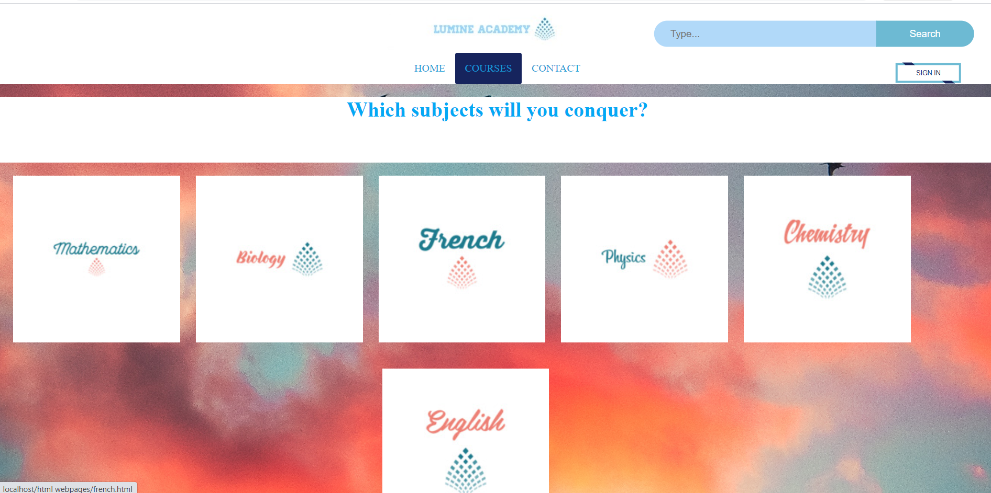

All these pictures are links. Each subject picture corresponds to the webpage of its respective subjects.

The Mathematics subject page’s layout below is similar for all the subject webpages expect French and English which do not have notes picture link.

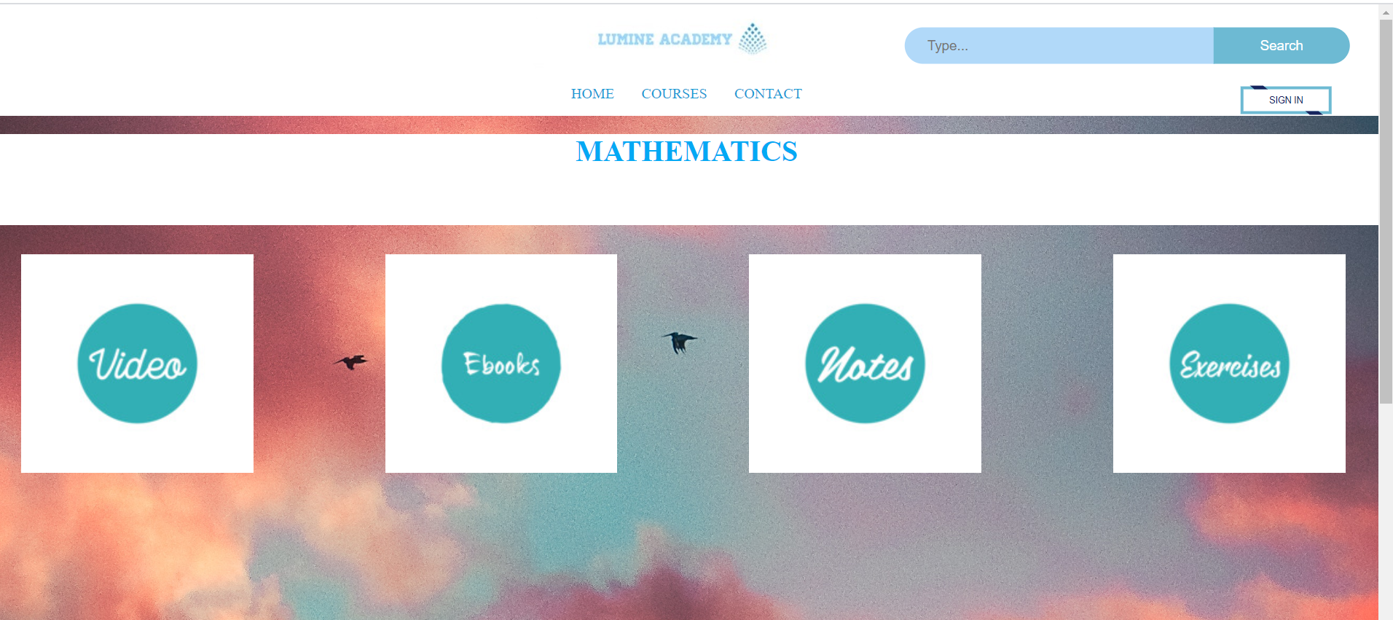

All these pictures are links directing to their respective resources’ webpage.

This is the Mathematics’ video webpage. All the other subjects’ video webpage have the same layout except for English and French which do not have the notes component in their subject resources navigation bar.

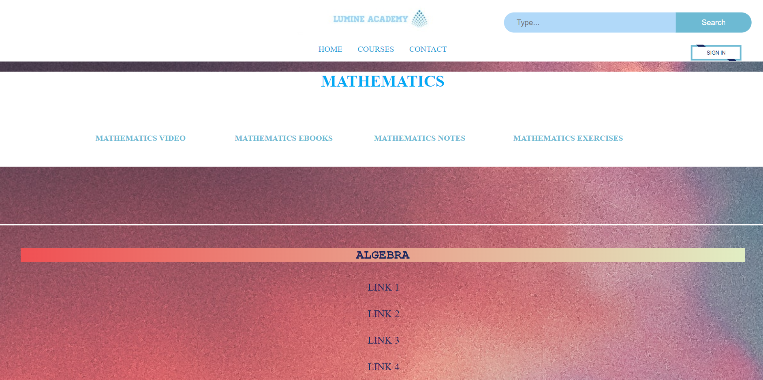

The videos are categorized chapter-wise.

These are video links directing to a new tab in the browser consisting of the video’s webpage.

All the components of this navigation bar link to its respective subject’s resources.

The eBook, exercise and notes webpages of each subject have the same layout format as shown below where each picture directs to a new tab consisting of the website having the resources.

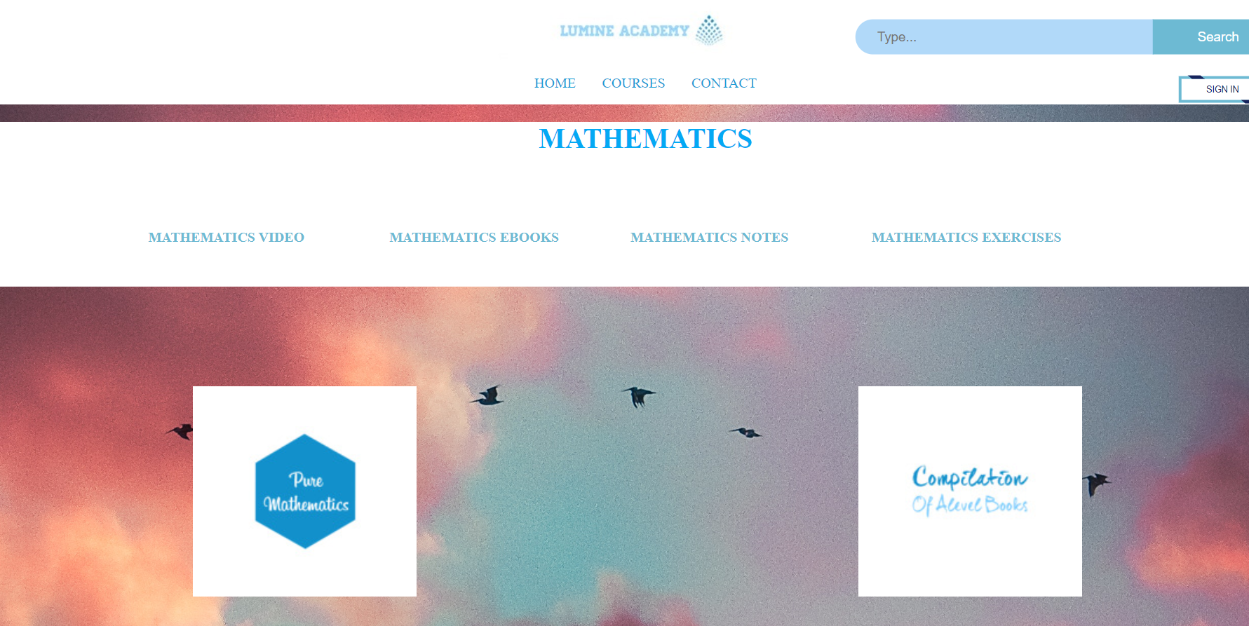

Contact page:

Fields criteria:

* Every fields are required fields without filling it, user will not be able to send the message.
* Email should consist of valid email with character before and after @ and @ as well else we will have error message.
* The phone number should consist of more than 7 integers

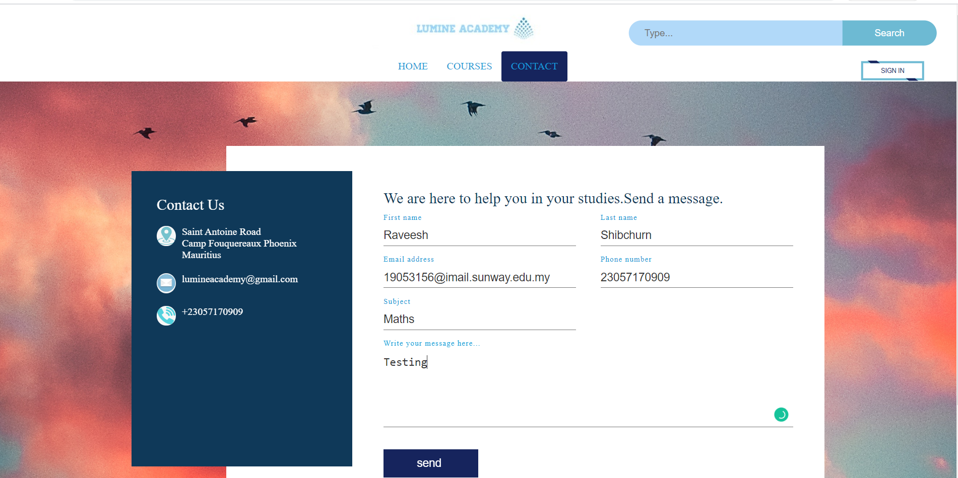

Click to submit

Sign in/Register page:

* Fields criteria for sign in form:
* Email should already be registered.
* Email should be valid with all normal email elements.
* Password should correspond to the email to log in.
* Password should be between 8 and 12 digits.

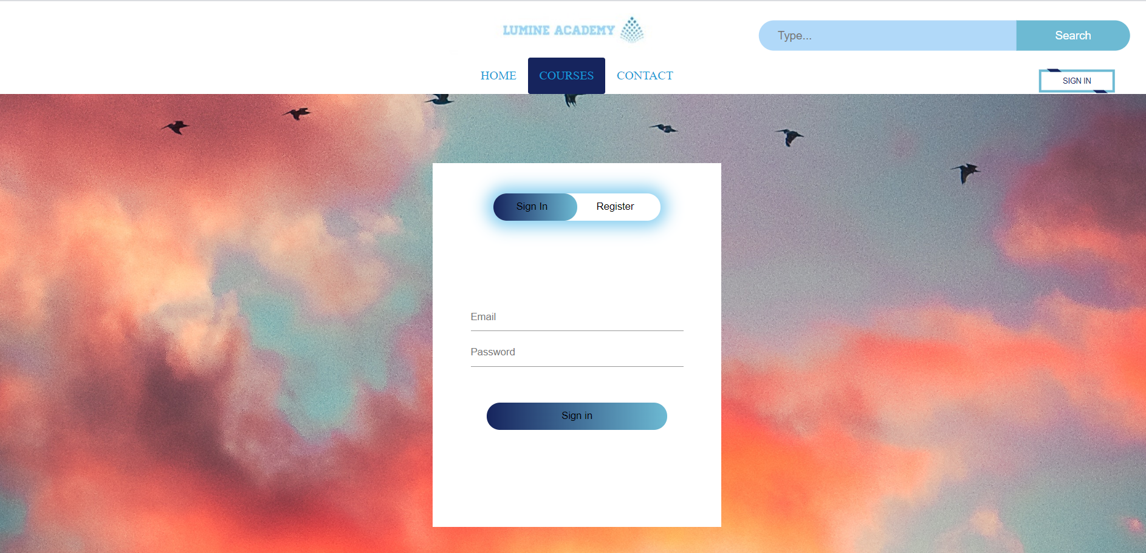

Click to sign in.

Fields criteria for sign in form:

* Password should be between 8 and 12 digits.
* Email should be unique and never registered in the system.
* Password should be entered twice and should match.
* Email should consist of all genuine email element.

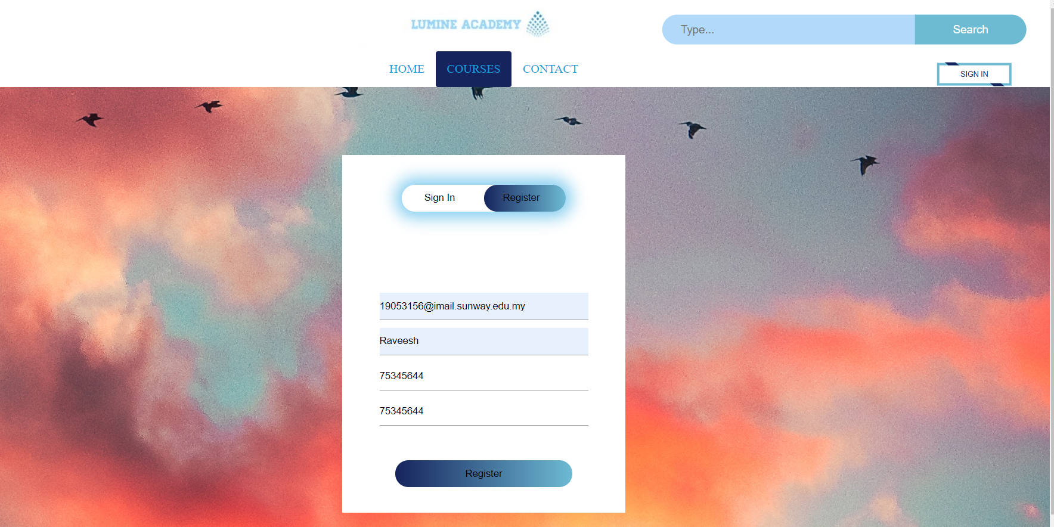

Click to register

Cases and results:

1. Registering and signing in successfully:

* Registering

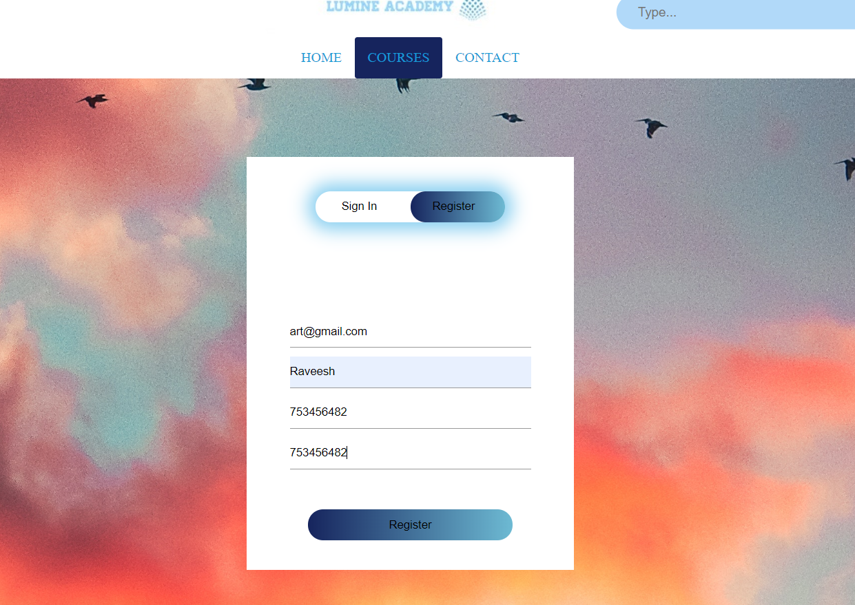

* Database

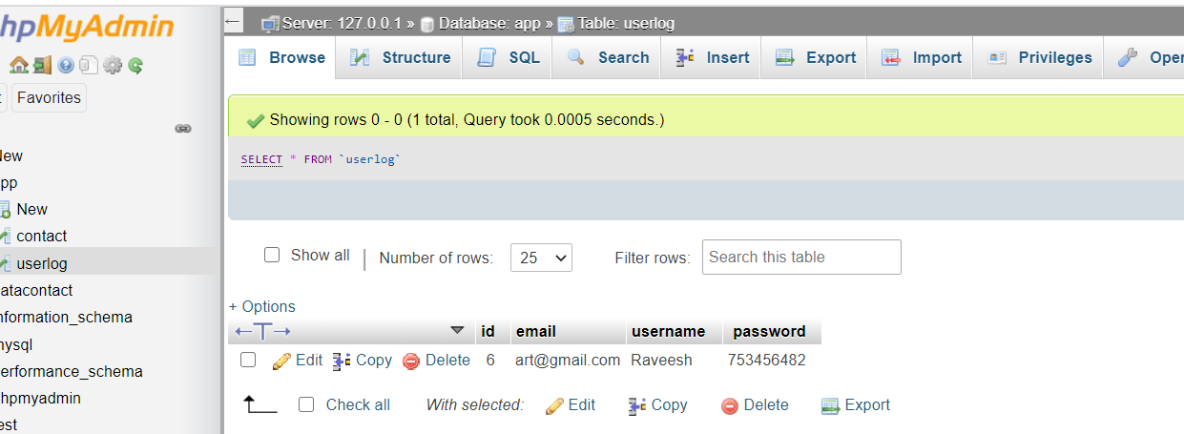

* Signing in

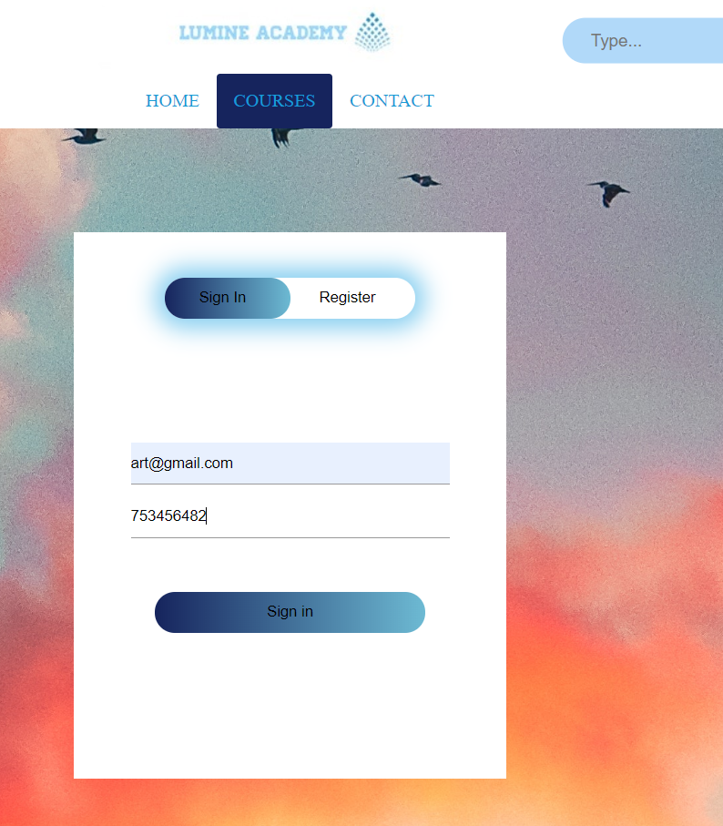

* Signing successful.

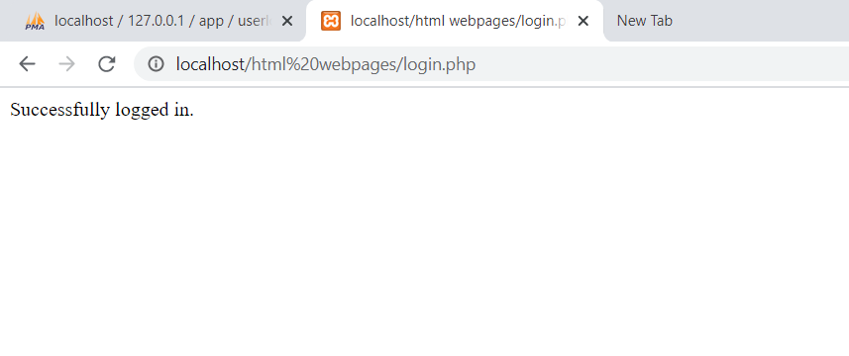

1. Signing in wrong password and invalid password:

* Inputting wrong password for above registered email.

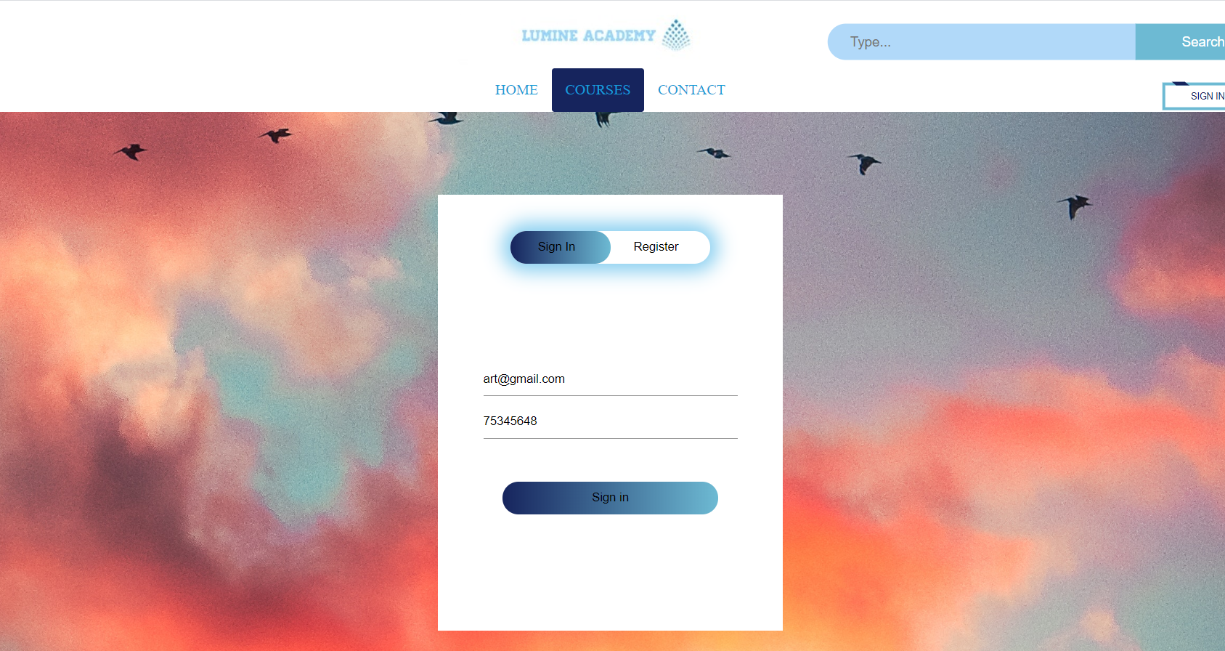

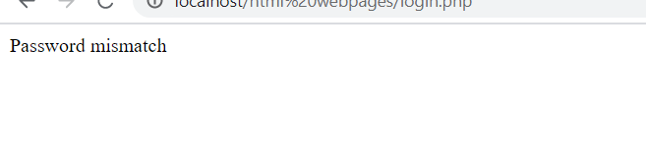

* Password length not within limits:

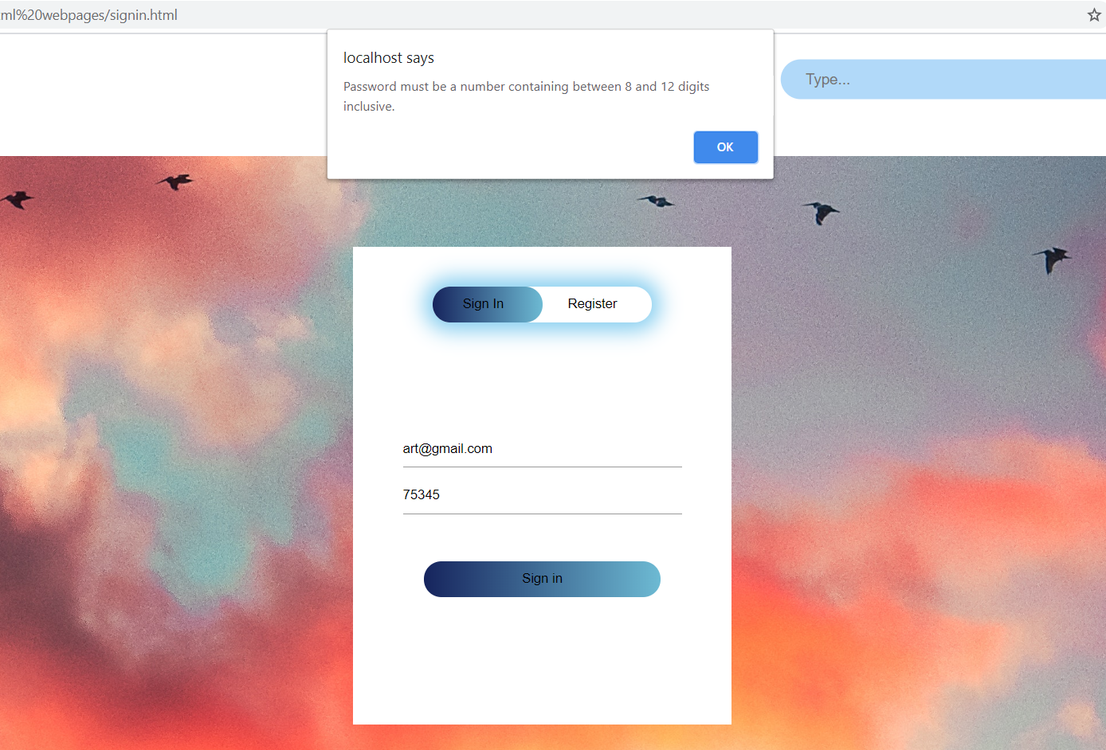

1. Registration errors:

* Email not having @

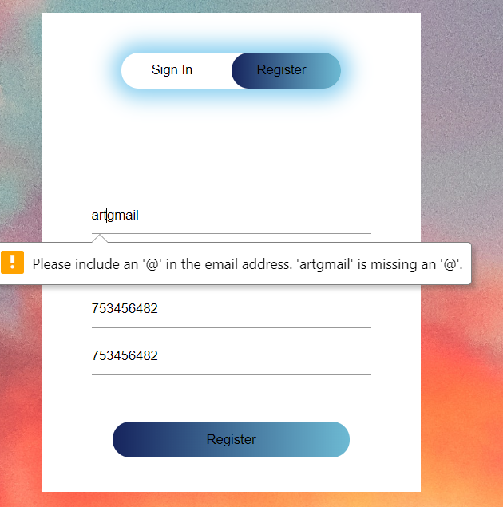

* Username not withing required length:

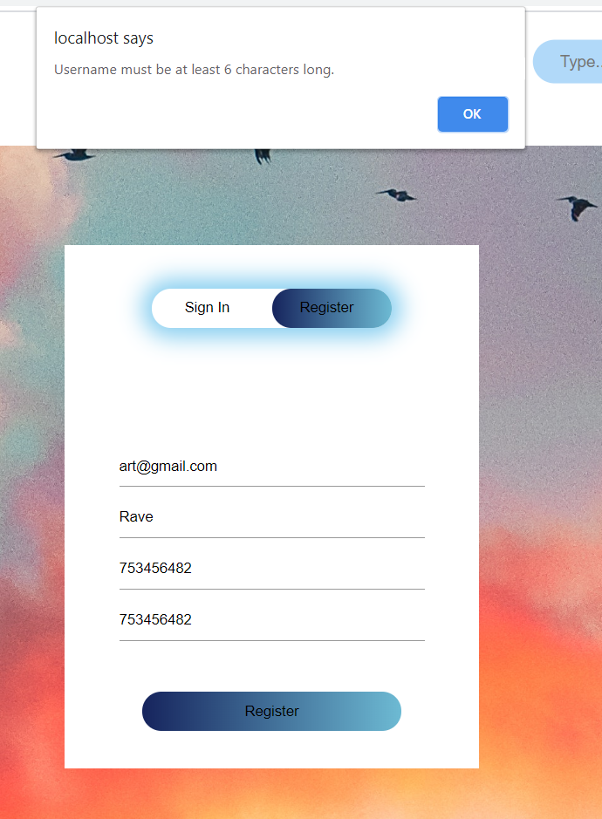

* Passwords not matching:

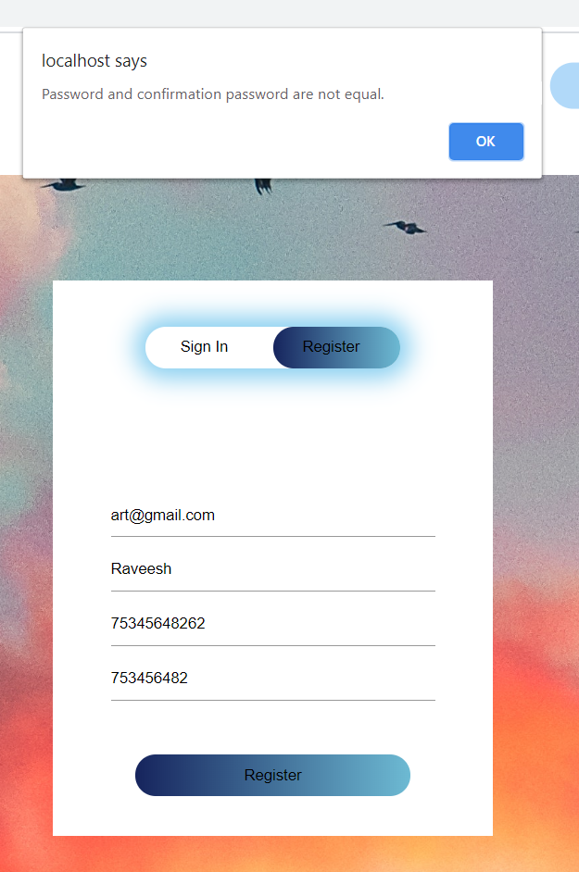

* Password length not within limits:

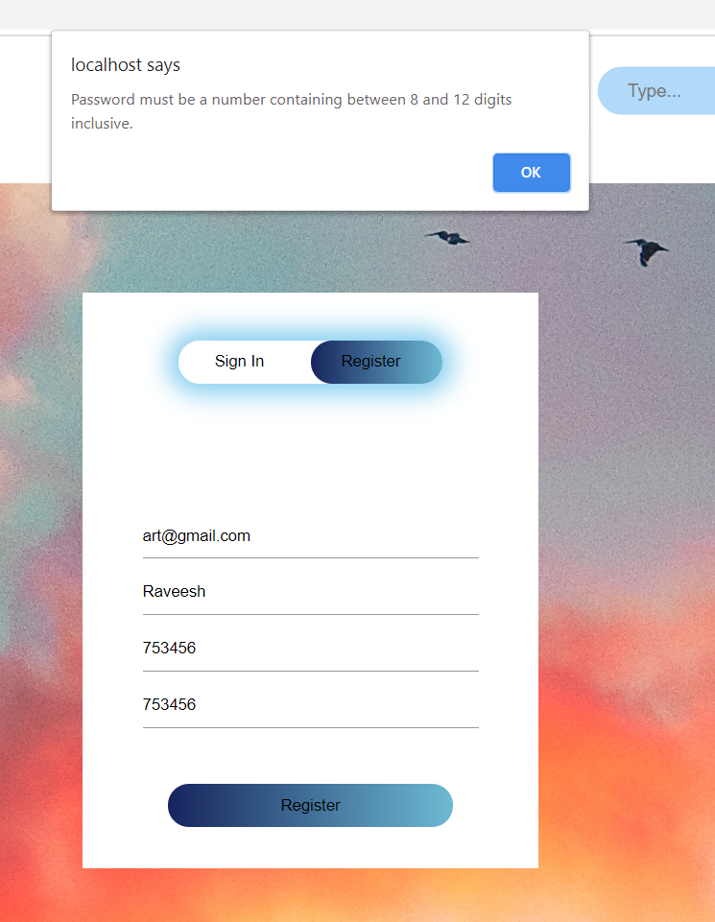

* Password not consisting of only integers:

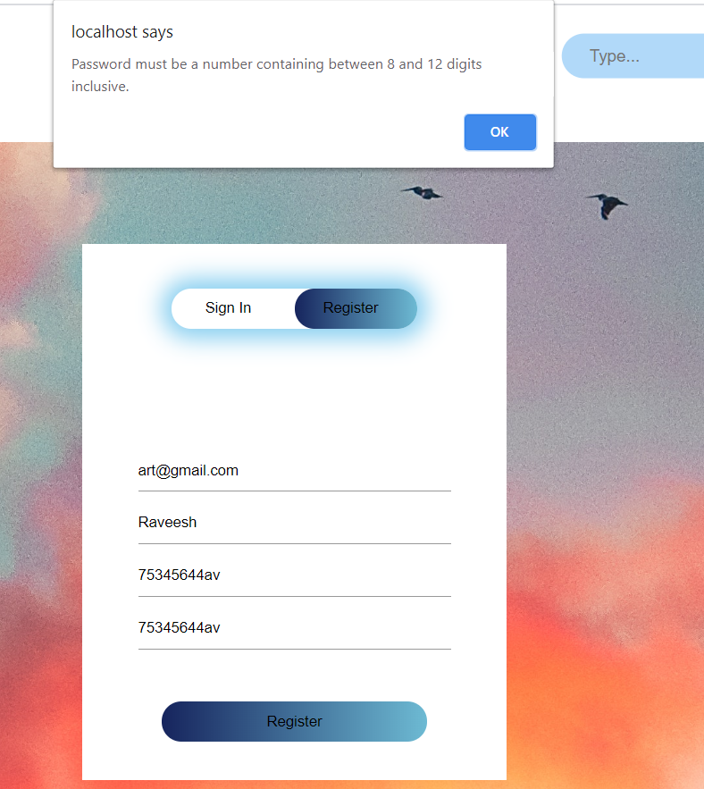

* Email already used:

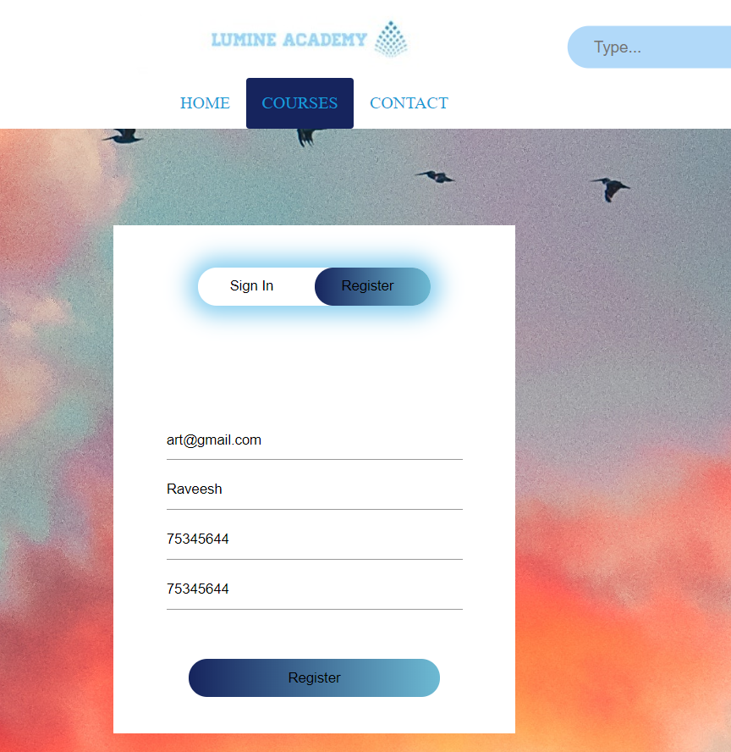

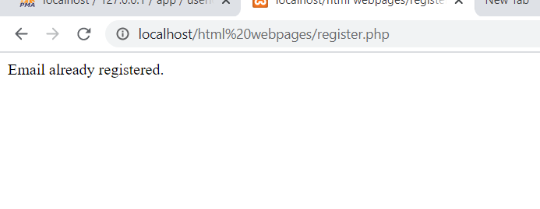

1. Contact form message sent successfully:

* Filling form

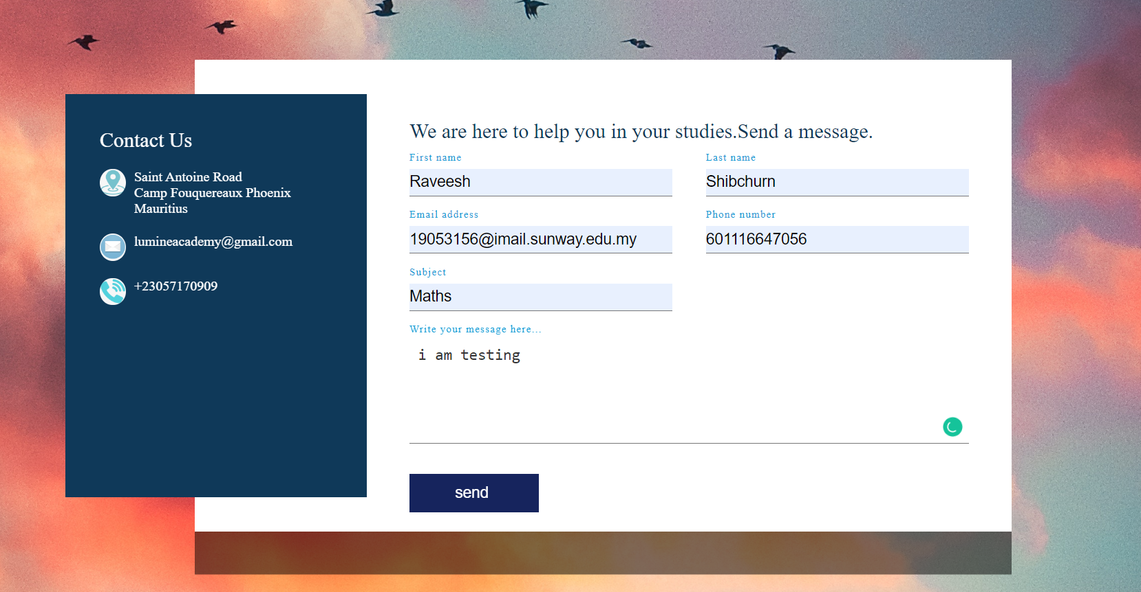

* Message sent

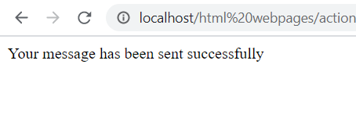

* Database

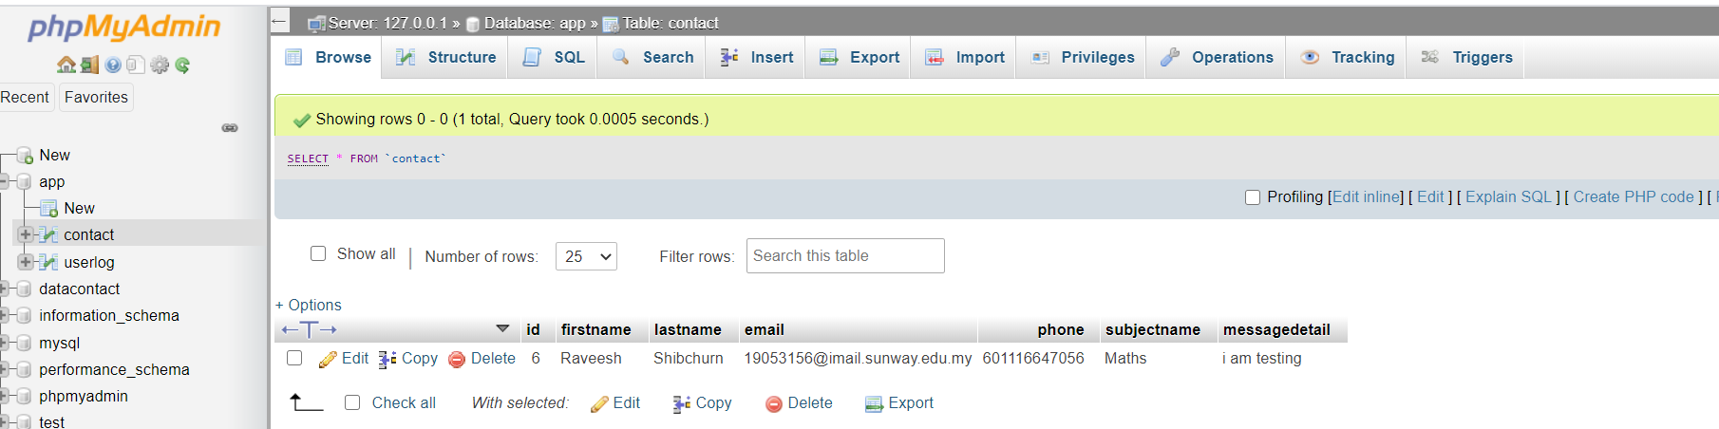

1. Errors in contact form:

* Should fill all fields else this message will pop near the field:

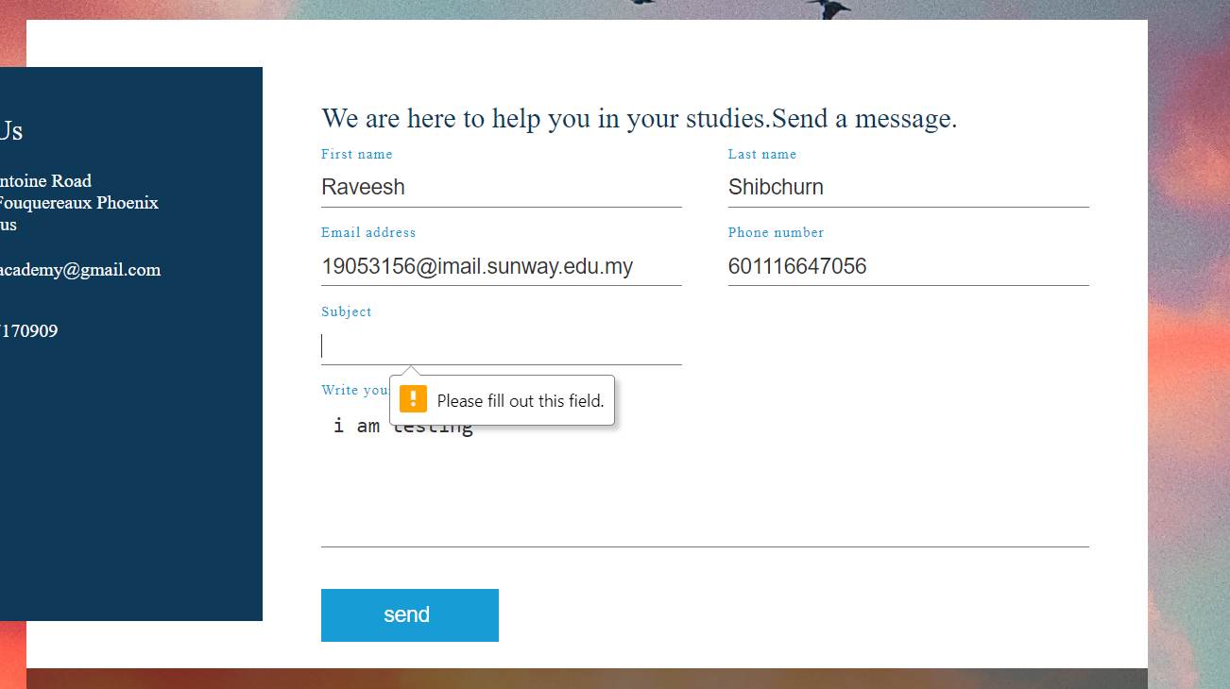

* Invalid phone number(should be greater than 7digits):

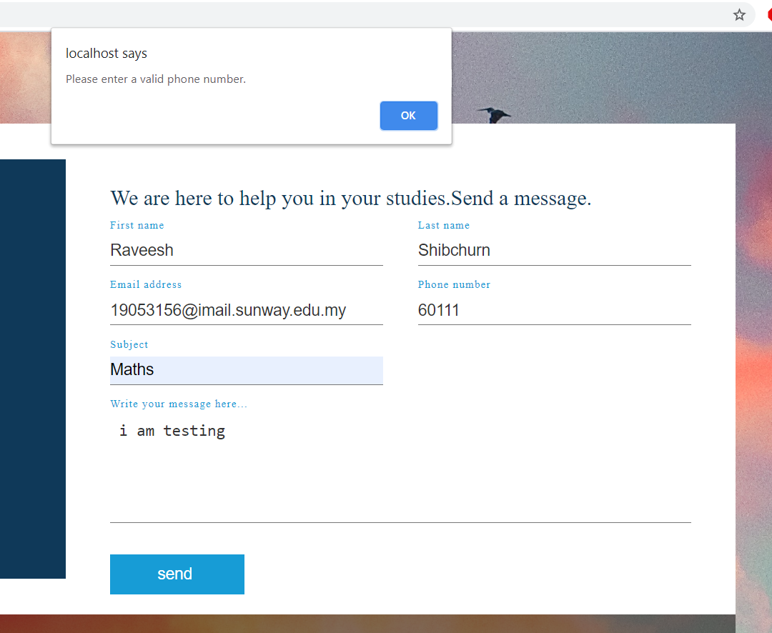

* Email error (should contain @ and characters before and after @)

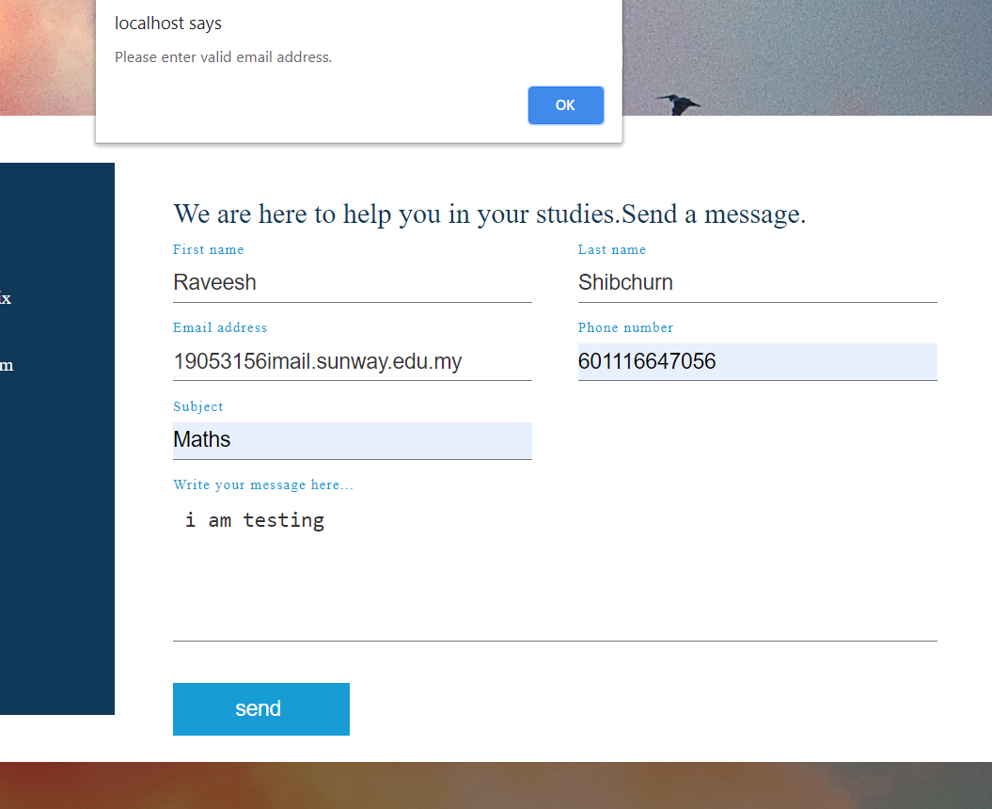

Conclusion:

The website as a whole works smoothly and is fulfilling the aim which is to bestow learning resources. The website is capable to allow user to log in and registered as well as allow unregistered and registered users to send message when having issues in learning. Afterwards, the website may consider having a log in system for teachers whereby they can add new resources on the website. Moreover, the website may consider changing the contact form so as to forward the subject issues message to respective subject teachers ,in the teacher log in system, who will have a better grasp of the subject issue since the educator is specialised in this field .

I did the referencing in the html codes by using the <! > code.

REFERENCE:

[1] URL: <https://www.youtube.com/watch?v=-6IgkG5yZfo&list=PL0o_zxa4K1BU6wPPLDsoTj1_wEf0LSNeR>

[2] URL:<https://www.youtube.com/watch?v=wWnfJ0-xXRE&list=PLyQSN7X0ro203puVhQsmCj9qhlFQ-As8e>

[3] URL: <https://www.youtube.com/watch?v=hSidjF-d-OQ&list=PLX2gX-ftPVXWtv0wrHIHTCUrZHUkVDJiZ>

[4]URL:<https://www.youtube.com/watch?v=2WS1sG9fhOk&list=PLqwfRVlgGdFAPyGw_KfVq13_2tuDVpfYD>

[5] URL: <https://www.youtube.com/watch?v=5-ZFOhHQS68&list=PLqwfRVlgGdFCqqzN5kxklreTBOnILQLiq>

[6]URL:<https://www.youtube.com/watch?v=XFhntPxow0U&list=PLqwfRVlgGdFBLZjZXvSItqix4Hs708vSD>

[7] URL: <https://www.youtube.com/watch?v=h2_I4QXmY3I>

[8] URL: <https://www.youtube.com/watch?v=PrixaY_sjvE>

[9]URL:<https://www.youtube.com/watch?v=NWCi2jUh2o8&list=PLGvD8d3gDHUWKVRa5ATicyKAdcWkM0AQS>

[10] URL: <https://www.youtube.com/watch?v=F_vLWkkOETI>

[11]URL:<https://www.youtube.com/watch?v=cYBQzMwoM_M&list=PLoGgviqq4845HXjP2hMrCCHw-koPsj7oY&index=7>

[12]URL:<https://www.youtube.com/watch?v=aUzsFD89gi4&list=PLWPirh4EWFpETqKKirdVbmZuCIpU6Jsyy>

[13] URL: <https://www.youtube.com/watch?v=3NY2aSIMVOo&list=PLX2gX-ftPVXWa7_h_WNtnEu5EZZGF8kQD>

[14]URL:<https://www.youtube.com/watch?v=ZcZQsj6YAgU&list=PLqwfRVlgGdFBHGEZdkmGzKGufuV5I3z0v>

[15]URL:<https://www.youtube.com/watch?v=garegCgMxxg&list=PLSQl0a2vh4HDlT0KK17cqkeIFVmsSzrta>

[16]URL:<https://www.youtube.com/watch?v=uLxDdQS0Tz8&list=PLWPirh4EWFpGFrujlRgqzQ8Pp9_IECugN>

[17] URL:<https://www.youtube.com/watch?v=j6sDLnNuFW0>

[18]URL:<https://www.youtube.com/watch?v=o0yfYTtR6go&list=PLGvD8d3gDHUVEYhaxVbQisdbaKJk1xRvB>

[19] URL: <https://www.youtube.com/watch?v=csMqfwJRjCs>

[20] URL: <https://www.youtube.com/watch?v=kLqduWF6GXE&list=PLF6C6594F42ECEE0D>

[21]URL:<https://www.youtube.com/watch?v=tQcB9BLUoVI&list=PLqwfRVlgGdFCs2ByAiC4bfGM3zSsbVcwF>

[22] URL: <https://www.youtube.com/watch?v=7Ul9T1-YaGA&list=PLP7MKjUAZ-wukRpN4jUcx4uZFAlAtLKqs>

[23] URL:<https://www.youtube.com/watch?v=jz92oOkJFNA>

[24] URL:<https://www.youtube.com/watch?v=m1PPujngqAw>

[25]URL:<https://www.youtube.com/watch?v=LXhYS7FhaE&list=PLGvD8d3gDHUUzllhbZQjHiawf9rIdmAqD>

[26]URL:<https://www.youtube.com/watch?v=7LyvAVjQUR8&list=PLUl4u3cNGP61FVzAxBP09w2FMQgknTOqu>

[27] URL:<https://www.youtube.com/watch?v=cPRFF-eCGT8>

[28] URL:<https://www.youtube.com/watch?v=WTQvfvoOF3g>

[31] URL: <https://studywise.co.uk/a-level-revision/chemistry/>

[32] URL: <https://www.askiitians.com/revision-notes/chemistry/>

[33] URL: <https://ocw.mit.edu/courses/chemistry/5-60-thermodynamics-kinetics-spring-2008/lecture-notes/>

[34] URL: <https://openedgroup.org/books/Chemistry.pdf>

[36] URL: <https://www.topfreebooks.org/free-chemistry-ebooks-online/>

[37]URL:<https://chem.libretexts.org/Bookshelves/General_Chemistry/Exercises%3A_General_Chemistry>

[38] URL: <https://web.nmsu.edu/~snsm/classes/exercises/>

[39] URL: <https://www.gceguide.com/>

[40] URL: <https://chem.libretexts.org/Bookshelves/General_Chemistry/Exercises%3A_General_Chemistry/Exercises%3A_Brown_et_al./25.E%3A_Organic_and_Biological_Chemistry_(Exercises)>

[41] URL: <https://www.tcyonline.com/tests/chemistry-exercises>

[42]URL:<https://www.youtube.com/watch?v=6pUzPh_lCO8&list=PLllVwaZQkS2op2kDuFifhStNsS49LAxkZ>

[43]URL:<https://www.youtube.com/watch?v=X96jN_pQJk&list=PL3MAPgqN8JWgT2jQkAx1VGUlcvlyz2Mpm>

[44] URL: <https://www.youtube.com/watch?v=Rd4a1X3B61w&list=PL166048DD75B05C0D>

[45]URL:<https://www.youtube.com/watch?v=5yw1YH7YA7c&list=PL0o_zxa4K1BVuX6wXQgyqZXvRd0tUUV0>

[46] URL: <https://www.youtube.com/watch?v=bka20Q9TN6M&list=PL0o_zxa4K1BWziAvOKdqsMFSB_MyyLAqS>

[47]URL:<https://www.youtube.com/watch?v=wJGR5YQqac&list=PLqOZ6FD_RQ7kGnKLTbdwZ3IGVNXK43k7S>

[48]URL:<https://www.youtube.com/watch?v=cAxJw_W05ZY&list=PL0o_zxa4K1BXP7TUO7656wg0uF1xYnwgm>

[49]URL:<https://www.youtube.com/watch?v=O8wKk6wkcEs&list=PL0o_zxa4K1BU3gxU8RwqkEET2ilZ80Znj>

[50] URL: <https://www.youtube.com/watch?v=pMoA65Dj-zk&list=PL7305D1BC80498DA6>

[51]URL:<https://www.youtube.com/watch?v=rHyIdxOzj9U&list=PLybg94GvOJ9GtvOUYLW601u1Oiaoat2UF>

[52]URL:<https://www.youtube.com/watch?v=6m9qoCkJZW0&list=PL0o_zxa4K1BW9NxZjS9ybwT0MVHVYcjvd>

[53]URL:<https://www.youtube.com/watch?v=tVcEEw6qbBQ&list=PLwL0Myd7Dk1HR9u5jw19E1_Q5u25PKg8v>

[54] URL: <https://www.youtube.com/watch?v=QpcACa39YtA&list=PL1O_shUH1zgX79aV-t8UiEfZyU6GE_Wvv>

[55]URL:<https://www.youtube.com/watch?v=aGYytZ7K7M&list=PLSQl0a2vh4HCZJ1YELKQaRt_n3wooLgn8>

[56] URL: <https://www.youtube.com/watch?v=y31DlJ6uGgE&list=PLlGavRTZEhd7QBL6HR8oPVG5eGOEt9GvW>

[57] URL: <https://www.youtube.com/watch?v=knv4fNNoEG8&list=PLbKSbFnKYVY25Xu3-g8SZzyvmhle-oYqA>

[58] URL: <https://www.youtube.com/watch?v=Q_BDXllUqJg&list=PLRVevJEMeSi_3e939uXtQg3jlkvYJth1r>

[59] URL: <https://www.youtube.com/watch?v=-KE7jTXwNYs&list=PLSQl0a2vh4HB_igUZHZ2xU4STOFqj7sbf>

[60] URL: <https://www.youtube.com/watch?v=bmeVQ7KhRto&list=PLmGAunhTA6-8YCdWsKCRHdOfvmL5JQk3p>

[61] URL: <https://www.youtube.com/watch?v=U5vAO_f2LDQ&list=PLbKSbFnKYVY0aJ8wpekSO4ssurkaIdeEk>

[62] URL: <https://www.youtube.com/watch?v=6gUY5NoX1Lk&list=PLkiXnK6bTM2l-8iP7t-vEufgeM2cU8ZJR>

[63] URL: <https://www.youtube.com/watch?v=NX0ZPtB_QFY&list=PLbKSbFnKYVY1nxvjyBMsq7PJ5Br0AMU8K>

[64]URL:<https://www.youtube.com/watch?v=8m6hHRlKwxY&list=PLwL0Myd7Dk1HK8gH2XIafNgQJD1dMX2aW>

[65] URL: <https://www.youtube.com/watch?v=iP6PtdhgzSk&list=PLKlDmF-iIyAk8YfEMiz4NYg7UNEF2sMsT>

[66]<URL:https://www.youtube.com/watch?v=LglQXHU5Umg&list=PLcqmJII16GiDziYQiyuDnzIzCFNQ3Byxe>

[67] URL: <https://www.youtube.com/watch?v=SJiXnnnI60g&list=PLzI8bbL3kqmHOPjdVHfmzXOyp8D28mgLn>

[68] URL: <https://www.youtube.com/watch?v=NJzJKvkWWDc&list=PLzPZN-I9h2F0aDDZBxIOomdqCVHrVhJRz>

[69] URL: <https://www.youtube.com/watch?v=nRpwdwm06Ic>

[70] URL: <https://www.youtube.com/watch?v=qGiPZf7njqY>

[71] URL: <https://www.youtube.com/watch?v=QYWNXp36O48&list=PL9IouNCPbCxVQPNgqka5bSs-IWe3L6OD8>

[72] URL: <https://www.youtube.com/watch?v=9axOFtPqS0c>

[73] URL: <https://www.youtube.com/watch?v=bW-eEBxJYaM&list=PL9jo2wQj1WCNaYmBK_B81PlrX4OYLwb13>

[74] URL: <https://www.youtube.com/watch?v=-KE7jTXwNYs&list=PLSQl0a2vh4HCKeX3g-Mj5wXS0nfDeDSGS>

[75] URL: <https://www.youtube.com/watch?v=-rsYk4eCKnA>

[76] URL: <https://www.youtube.com/watch?v=GSp_YeYtLmo&list=PLKlDmF-iIyAl5olxhgcqlRO6izB_yoWI0>

[77] URL: <https://www.youtube.com/watch?v=oq7cIxz_7-k>

[78] URL: <https://www.youtube.com/watch?v=eEUvRrhmcxM>

[79] URL: <https://www.youtube.com/watch?v=GcjgWov7mTM&t=15s>

[80] URL: <http://www.freebookcentre.net/Biology/Biology-Books-Online.html>

[81] URL: <https://biology-igcse.weebly.com/pdf.html>

[82] URL: <http://biology4alevel.blogspot.com/>

[83] URL: <https://www.ets.org/s/gre/pdf/practice_book_biology.pdf>

[84] URL: <http://www.biology-resources.com/biology-questions.html>

[85] URL: <https://manybooks.net/>

[86] URL: <https://www.easypacelearning.com/english-books>

[87] URL: <https://www.learncbse.in/class-12-english-chapters-summary/>

[88] URL: <https://www.perfect-english-grammar.com/grammar-exercises.html>

[89]URL:<https://www.youtube.com/watch?v=GgkRoYPLhts&list=PLk0TOXGeAF848nM3WaM3DKNjuZ9JQfWxh>

[90]<URL:https://www.youtube.com/watch?v=xay5TeJVSC0&list=PLD6t6ckHsrubRV7Wb42ggOhVNrBRAte13>

[91] URL: <https://www.youtube.com/watch?v=eGWO1ldEhtQ&list=PLN3kZ8bfmMJN2-EdLyE7_rOZo8o3IpFlv>

[92] URL: <https://www.youtube.com/watch?v=QXnsw4cn5wo&list=PLeVxAnFsasIqIc8b03kHA3tw-xfIwgO2M>

[93]URL:<https://www.youtube.com/watch?v=tiV5v2c6T6Q&list=PLoGgviqq4845L7Yj9c1kkIfdskkaLOUzD>

[94] URL: <https://www.youtube.com/watch?v=4w4TPk4qM5c&list=PLYB1bILo6eLPCcH9_4T6-vfCTEa56tYhR>

[95]URL:<https://www.youtube.com/watch?v=lN4Kpj1PFKM&list=PLjLHo7a7HFOv0surv9nxlEzaeeqO_DlXF>

[96]URL:<https://www.youtube.com/watch?v=7swhS_DSWqI&list=PLswCVWtC7kMTttFwBVnxneXujDEapufhz>

[97] URL: <https://www.youtube.com/watch?v=9IsgusPAFx0&list=PL5bLw9Uguvv0Q6yEZUcNMs0uQDYpffIx4>

[98] URL: <https://www.youtube.com/watch?v=_IK_0sIsfxg&list=PLpLRk365gbPaY0U_9zYYRY5JmStMZ9NSI>

[99] URL: <https://www.youtube.com/watch?v=O-6q-siuMik&list=PLh7K1tEhkxF0UqPX5Yi-0zEsKJZFhzw-q>

[100] URL: <https://www.youtube.com/watch?v=jul2urONzOQ&list=PLD6t6ckHsruY_i7_rZhKcRBmXDdawiqUM>

[101] URL: <https://www.youtube.com/watch?v=rjWd8U-6jbA&list=PL6BDo90oiwpS4_AM1c0s0ozpROeE2A9ff>

[102] URL: <https://www.youtube.com/watch?v=7jbStLLnNUo&list=PLfQSN9FlyB6SEBVnec8LYuyLRvq3OcT-x>

[103] URL: <https://www.youtube.com/watch?v=APuN--iG9H0&list=PLGy3OYuEsUIDMdmXkkUwXBIJe5g_okxwL>

[104] URL: <https://www.youtube.com/watch?v=KaA_mxga3PQ&list=PLD6t6ckHsruYoalxbzcjX1TNn4h7ShiRk>

[105] URL: <https://www.decitre.fr/ebook/bonnes-affaires/ebooks-gratuits.html>

[106] URL: <https://www.bonjourdefrance.com/index/indexgram.htm>

[107] URL: <https://www.francaisfacile.com/exercices/>

[108] URL: <https://www.toppr.com/guides/maths/>

[109] URL: <http://tutorial.math.lamar.edu/>

[110] URL: <https://www.gceguide.xyz/cambridge-international-level-physics-2nd-edition>

[111] URL: <http://www.freebookcentre.net/Physics/Physics-Books-Online.html>

[112] URL: <http://problemsphysics.com/>

[113] URL: <https://www.syvum.com/squizzes/physics/>

[114] URL: <https://openstax.org/books/college-physics/pages/4-problems-exercises>

[115] URL: <https://byjus.com/cbse-notes/physics-notes-pdf/>

[116] URL: <https://www.scrantonproducts.com/color-psychology-classroom-colors-conducive-to-learning/#:~:text=Results%20have%20shown%20that%20different,calming%2C%20while%20red%20encourages%20excitement.>

[117] URL: <https://www.shiftelearning.com/blog/how-do-colors-influence-learning>